July 27, 2025
C964: Computer Science Capstone

Task 2 parts A, B, C and D
Part A: Letter of Transmittal 2
Part B: Project Proposal Plan 4
Project Summary 4
Data Summary 4
Implementation 5
Timeline 6
Evaluation Plan 7
Costs 8
Part C: Application 9
Part D: Post-implementation Report 10
Solution Summary 10
Data Summary 10
Machine Learning 11
Validation 12
Visualizations 13
User Guide 16
Reference Page 18

Part A: Letter of Transmittal
7/27/2025

Ethan West, CEO
JobFinder Inc.
120 N. Wildwyrd Rd,
Phoenix, AZ 89512

Dear Mr. West,
JobFinder Inc. has always prided itself on being one of the best websites for job seekers to find technology-specific careers. A place where up and coming developers and programmers could find relevant posting that gives the best opportunities to get an interview. However, with the job market as it is and the constant changing of job titles it could be challenging for new grads to find a career that matches their chosen skill sets. Without ways of easily finding a job title that matches their technological abilities they could become discouraged and leave our site without engaging further. If a user leaves JobFinder without a feeling of satisfaction, then there is a higher chance that they will not return to the website in the future.
The proposed solution to this problem is a machine learning project that offers insights into information about job postings to users which would be invaluable to keep users involved with JobFinder. This solution will be a dashboard that provides users with tools that they could use to gain further insight into the jobs that they could be searching for and apply for. This dashboard will provide users with three ways of understanding the current tech job market through graphs. A bar graph will show the top 20 states in America that have the highest number of jobs offers. Another graph will be a pie chart that shows the user the top 10 job titles that are posted by companies. A third graph will be another bar graph to display the top 15 companies that are making job posts. There will also be a more interactive user interface section where users can input the top skills such as programming languages, they are proficient in and be able to enter that into the dashboard. The dashboard will then present them with the most relevant job titles for them to search. All this will be done utilizing a logistic regression algorithm to make targeted predictions.
This solution will benefit JobFinder Inc. by increasing user satisfaction using our website, increasing the number of user applications submitted through JobFinder, and increasing the number of employer responses to those applications. All of those metrics will mean that JobFinder is building and retaining that userbase. An increase in user activity on the website will result in increased ad revenue and users involving themselves with JobFinder’s premium subscription features. This proposed machine learning (ML) solution will benefit our userbase by giving them a more in-depth analysis of the current tech job market. This analytical information will allow them to focus on areas during their career search such as what states have the most job offers or what jobs are the most posted. This will help users learn what skills they could learn to become more marketable to employers. With the ability to have a more targeted search to the user’s own tech skills will allow them to find jobs that they might not have known of previously. This will increase user satisfaction as this proposed solution will allow them to find and apply for jobs that are specifically looking for their skillset.
The requirements to develop, implement, and maintain this solution will cost about $13,600 plus an additional $2,400 per year. These costs will consider the costs of infrastructure, project development, testing, documentation, legal, and labor time. For labor costs, this will be paid to the developer who is being proposed to develop and build the proposed solution. The software developer has four years of experience involving both educational pursuits and professional ones. Going through both an Associates of Applied Science degree in programming and systems analysis as well as completing a Bachelor of Science degree in Computer Science. This developer will complete this ML solution project in a proposed timeline of three months.
Sincerely,
Zachary Grootegoed
Zachary Grootegoed
Junior Software Developer
JobFinder Inc.
120 N. Wildwyrd Rd,
Phoenix, AZ 89512

Part B: Project Proposal Plan

Project Summary
JobFinder Inc. is a company that specializes in gathering job postings specifically in the tech industry in the United States and displaying them to users in an easily accessible manner. This allows both new grads and experienced professionals to find relevant job posts without having to filter through unrelated ones. JobFinder Inc. routinely checks to ensure that the postings are up to date and not scams through a series of checks. These job posts are made by hiring companies and HR departments. The company also has a premium subscription option that allows users with created accounts to gain insights into their own profiles and resumes.
However, the website is suffering from a lack of returning users and retention. This is due to a lack of both specific targeting and user job market understanding. Job titles and required skills for those careers are constantly changing to go along with industry trends. Therefore, a dashboard that will utilize a machine learning solution could provide a targeted approach to finding jobs and their associated titles. This dashboard could provide both a way for users to search for jobs by their skills to learn about titles and have a better understanding of job posting trends. Trends such as which states have the most offerings or which titles have the most postings. These dashboard features will increase customer satisfaction with using JobFinder Inc. A benefit will be that a customer who thinks there is value in using the webpage will be more likely to return and engage in premium services.
The proposed solution deliverables will include a hosted dashboard with an interactive element for the users to enter their skills, three graphs which will include detailed information on the jobs being posted, and a machine learning application for predicting jobs based on skills. The graphs will describe which states have the most offerings in a bar graph, the most job titles currently posted in a pie chart, and a second bar graph for skills for jobs. The machine learning solution will be used for when the user enters their skills to output the top three job titles. Documentation about the dashboard as well as a user guide on how to both install and use the application will be provided.

Data Summary
The source of the data originates from JobFinder’s own job board and is kept on a MS SQL Server. These come from companies creating and publishing their job postings with all the required relevant information. This data is pulled from the company’s own SQL data pipeline which is updated on a weekly basis. The data will go through the extract, transform, and load (ETL) process. When it gets pulled, it will output to a csv file that goes to project code directory. There the dataset will be transformed and cleaned so it can be used in the machine learning algorithm. Once loaded into the solution, the information will be used for the dashboard.
The data fields that will be pulled include:
- Advertise URL
- Company
- Employment Type
- Job Description
- Job ID
- Job Location
- Job Title
- Posted Date
- Job Shift
- Site that the job was posted on
- Skills
- Unique ID
This data meets the needs of the project as they are required in order to be relevant to the users trying to use the project solution. The fields for this dataset meet the needs of the project as they are all applicable to what a user would need to find value in this proposed dashboard. The machine learning algorithm requires both the job title, job description, and skills in order to be trained and have an accurate output. Any incomplete data will be dropped from the data pull. However, missing data in the shift or site name will be auto filled with ‘see job description’. The reason behind this is that all the data that is missing rows will have more information in the description.
The data that is being stored will be inside MS SQL Server before being output to a csv file. MS SQL Server has its own authentication and security features for the protection of data. However, for this proposed solution there is no sensitive data being utilized for the dashboard. It is not recording the user’s account utilizing the features. There is no personal identifiable information being kept in or used by the machine learning algorithm.

Implementation
The industry-standard methodology that will be used for implementing this proposed solution is the CRISP-DM methodology. This methodology is a widely accepted and used framework for designing and deploying machine learning or data mining projects. There are 6 phases of this methodology: business understanding, data understanding, data preparation, modeling, evaluation, and deployment. One reason that this methodology will be chosen is that according to Starbust, “CRISP-DM is considered a more flexible and comprehensive framework, suitable for a wide range of data mining and machine learning projects.” (Ng, 2023). This flexibility will allow for this methodology to be used for this proposed solution and focus on the project lifecycle was why it will be chosen over other industry standard methodologies.
Business understanding is the first step of the CRISP-DM methodology. In this step, business requirements will be gathered through a series of meetings with stakeholders. These meetings will help determine what exactly is required for this project to be considered successful and valuable. This step also includes determining what resources will be available for the project and which ones will be selected. These selected resources will be detailed in the project plan. A timeline for the life cycle will be written up in that project plan. The overall costs will go through analysis to understand what it will take to develop the solution and will be presented in the proposal. This will be the foundational step of the project. The measures of success for this project will include if 50% of the user base have interacted with the dashboard and 75% of them are satisfied in a two-month period, an increase of 15% of new user accounts created, and a 10% increase in applications submitted to job posting on JobFinder in a three-month period.
Data understanding is the second phase of the chosen methodology. In this step, which data sets to be chosen and analyzed will be determined. The origins of the data will come from JobFinder Inc.’s own SQL server where it can be exported to a csv file. The data will be acquired through the data import pipeline and described. Here the properties of the data such as column headings and what is contained in the rows will be analyzed to understand how this set will work within a potential machine learning model. Exploring the data to investigate whether the set is going to require cleaning or not will be done in this step. Once a solid foundation of understanding the data set is formed, the project will move onto the next step.
Data preparation will be about doing what will be required to make the data set viable for use in the machine learning model. With a data set being chosen, it will not go through the cleaning process. Here missing values will be dropped from the set, besides the shift and site name sections. If those sections have missing values, then they will be replaced with a simple string value. This will be done in order to minimize the number of drops sections as those two parts will not be as needed as the others. Then a function will be written that normalizes the data, such as turning the data into all lowercase. For job titles, the program will go through the list and find the ones that are the most frequent. This will be done to help the model be more precise in its classifications and predictions. Lemmatization and stemming methods will be done for that same reason. Those techniques will be incorporated into the preparation in order to reduce the words into their base forms to help with a future interactive element as well as make it simpler for the machine learning model. The data will then go through a text classification to ensure that the data is categorized for the logistic regression model. “In the context of text classification, it helps us to determine whether a piece of text belongs to a category or not (such as spam or not spam, positive or negative sentiment).” (Lee, 2024).
Modeling is the nest step of the methodology. In this step, the developer will be creating the machine learning model. Research will be done to determine which algorithm will be best suited for the needs of the project. After careful deliberation and the algorithm is chosen, then the data will have to be split. What specifically will the model be trained on, such as skills or job title. Training and test sets will be created. Then the model will actually be built utilizing Python’s open-source library options. As the ML model is trained it will then be assessed. A determination will be made to see if the model meets the library’s pre-defined success criteria.
The next phase is evaluation. In this step of development, the created and trained machine learning model will be evaluated. It will be checked to see if it meets the needs of the business and stakeholders. The graphs and interactive sections will be shown to the business users to determine if they are valuable. If they pass evaluation, then a review overall the all the work will be done. Here the programming will go through another check to ensure the completeness of the work that was done. The team will be presented with performance measurements of the model and discussions about its precision, recall, and accuracy will be made.
The last step is deployment. Here the model will be uploaded and deployed to the chosen hosting platform. The final documentation will be written including a user guide to ensure efficient use of the solution project. Finally, a plan for future maintenance to monitor changes in the program whether for coding updates or for any potential bugs to be fixed in a timely manner. The final report will be produced and signed off on. This step will ensure the continued effectiveness of the machine learning dashboard.

Timeline
Milestone | Start Date | End Date | Duration
Requirements gathering | 7/28/2025 | 7/29/2025 | 16 hours
Project Proposal | 7/30/2025 | 8/5/2025 | 40 hours
Data csv is pulled and imported | 8/6/2025 | 8/19/2025 | 80 hours
Data is cleaned and transformed | 8/20/2025 | 8/21/2025 | 16 hours
ML model prototyped | 8/22/2025 | 8/28/2025 | 40 hours
ML model finalized | 8/29/2025 | 9/4/2025 | 40 hours
ML model is trained | 9/5/2025 | 9/11/2025 | 40 hours
ML model tested | 9/12/2025 | 9/16/2025 | 24 hours
Graphs are developed | 9/17/2025 | 9/17/2025 | 8 hours
Interactive element is developed | 9/18/2025 | 9/19/2025 | 16 hours
Project is hosted and tested | 9/22/2025 | 9/24/2025 | 24 hours
Project is deployed and tested | 9/25/2025 | 9/26/2025 | 16 hours
User Acceptance testing | 9/29/2025 | 10/2/2025 | 32 hours
Modifications made based on feedback | 10/3/2025 | 10/7/2025 | 24 hours
User guide and documentation | 10/8/2025 | 10/8/2025 | 8 hours
Final project signed off | 10/9/2025 | 10/10/2025 | 16 hours

Evaluation Plan
The verification methods are an important step of the development stage used to ensure that the features are working as specified in this proposal document. Methods that will be used during the majority of developments will include reviews and inspections. Walkthroughs for the requirements gathering to ensure that both the team and stakeholders are all on the same page, which is an important first step in the process. All verification methods will be done before the validation one at each step, this is to ensure that everything is working as intended or to the specifications addressed in this document. Each piece of the software portion of the project that is completed will be reviewed to make sure that it is actually working as it is supposed to, which will enable the programmer to discover bugs in the early stages of the development process.
The validation methods are a second step to ensuring that the project is working as intended. One method that will be used is unit testing. This means that every piece of the project will be isolated and tested to make sure they are both bug free and functioning per the requirements. Portioning the project off into smaller pieces will help with discoverability of bugs, allowing the developer to efficiently fix them. This form of validation will discover if the interactivity of the dashboard is providing the correct outputs for the required results for this project to be successful. Another method of validation that will be done is end user acceptance testing. This will be the dashboard being used by stakeholders and users.
Metrics for evaluating if this project is successful will include users being emailed a questionnaire for if they used this dashboard and their satisfaction with it. This will help determine the satisfaction of customers with this new feature, if 50% of users have interacted with it and 75% of satisfied with it in a two-month period then that is a success. Another validation metric will include 15% in new user accounts created and a 10% increase in applications submitted to job postings in a three-month period. These metrics will be used to determine if the project has achieved its primary goals of increasing customer satisfaction and building a returning userbase for JobFinder Inc.

Costs
Resource | Description | Cost
Labor costs | Salaries for hours worked for Junior Software Developer  ((8 hours per day * assuming 55 weekdays) * (hourly salary) | ($21.87 per hour) = $9,622.80
Software costs | Windows 11 OS, MS SQL Server Database, Python 3.13.4 | $0
Hardware costs | Laptops, Servers, Storage drives, and physical upgrades to devices | $0
Network usage costs | Automated recurring tasks for data pipelines | $1,500.00
Integrated Development Environment costs | PyCharm Edu 2021.3.2 | $0
Hosting costs | Google Colab, MS SQL Server (JobFinder’s current database platform) | $0
Deployment costs | Binder, JupyterLab | $0
Documentation costs | GitHub Premium Subscription, Microsoft 365 Office Standard Subscription | $278 + $150 = $478.00 (yearly)
Maintenance costs | Bug fixes, Security updates, performance improvements, and other updates | $2,000 (yearly)
 | Total: | $13,600.80  ($2,478 yearly after the first year)

Part C: Application
The Python project code was developed on Google Colab. All the relevant files were uploaded to a public GitHub repository so that the data csv file could be pulled from there. For hosting a JupyterLab page, a website called Binder was utilized. This web application can pull the files from that Github repository and create that JupyterLab page.
Google Colab Link:
https://colab.research.google.com/drive/1kssoga2Tt6zUFbQS-Ft1ByZ-Kt8lEgJL?usp=sharing
Binder/Jupyter Lab Link:
https://2i2c.mybinder.org/v2/gh/ZGrootegoed/Capstone/main
Github Repository:
https://github.com/ZGrootegoed/Capstone

Part D: Post-implementation Report

Solution Summary
The job market is often confusing and difficult for both new grads and experienced professionals to navigate. Titles change with the introduction of new technologies and industry practices making it hard to discover which jobs one should be applying for. JobFinder Inc. advertises itself as a place where people can find relevant jobs but with the competition for tech-based jobs continuing to rise it is important for applicants to focus on their marketability and skills. Before this solution, JobFinder Inc. had no way for applicants to discover careers by their skills nor had any way of understanding the current job market. This lack of features decreased customer satisfaction and caused the company to lack returning users. Since users were not being retained meant that the premium features of the company were not being engaged with as much as they could be. Therefore, this dashboard became the solution to those issues.
This application provided users with a greater detail of understanding of the current job offers on JobFinder Inc. It presented them with three different graphs to give trends such as which states have the most job postings, which job titles have the greatest number of postings, and one for the top 15 companies that make job posts. This will help users understand which US locations are the best to search for jobs as well as which jobs are the most in demand. This greater visibility over the market helped tackle feelings of being overwhelmed and confused. The machine learning aspect of this application utilized a logistic regression algorithm to match skills with titles from the data being pulled from the Dice.com csv file. This is accessible in the interactive section of the dashboard where users are requested to input a set of skills and then presented with the top five matching job titles. This feature solved the problem of users not being able to find a job by their skills that they believed to be most marketable. This dashboard application increased user satisfaction in the company as the functionality is relevant to their job search. With a believed increased value in the business, users are returning to the website.

Data Summary
The raw data that was used in this machine learning solution originated from JobFinder Inc.’s own MS SQL Server. This server stores the data after a company makes a job posting on the website. This data is stored in table formats with headers. The data that was required for this solution was all stored on a single table with easily understood head elements. SQL Server has its own export wizard window that comes with the SQL Server Management Studio already accessible by JobFinder. Here the data was exported to a csv file with all the relevant columns and rows. After reviewing the exported file, a plan was formed for what columns needed to go through the cleaning process. It was determined that the shift, site name, and job id rows would need specific changes such as filling null rows or cutting the beginning portion of the job id string. All the other sections would be dropped if they contained a missing row. The csv file was imported into the project via using the open-source Python library pandas which allowed for data manipulation and analysis.
The exact changes to the data involved replacing the empty rows in shift and site name with a message to see the job description. The rows with a missing value were dropped using the dropna feature. The job id was cleaned by cutting out the beginning string value so as to normalize the rows and make it more easily readable. Further cleaning for the skills and job titles was necessary for the logistic regression model to be precise. Both of those columns were lowercased before going through the regular expression function. This RegEx function only kept the data in those rows there were lowercased and characters that included a plus or hashtag. This was because some skills included non-letters like C++ or C#. Next only the job titles were there were at least twenty instances were kept. This was to narrow down the giant sample field into something more manageable by the logistic regression model. This was done after seeing the accuracy and precision was not at an acceptable rate. When this restraint was added to the titles column, the model significantly increased in its performance.
Then the skills went through a stemming and lemmatization process. IBM discussed these processes as, “Both stemming and lemmatization strip affixes from inflected word forms, leaving only a root form. These processes amount to removing characters from the beginning and end of word tokens.” (Murel & Kavlakoglu, 2023). Converting the skills words to their base forms not only helps the ML algorithm but will also be essential for the interactive element as users might enter the skill term in a slightly different way than what’s in the database. The next step involved encoding the job titles. Then the model was training using the skills as the x and the labeled jobs as the y sets that went into the train_test_split function. Finally, the logistic regression algorithm was trained through a pipeline to first convert the non-numerical data using the tfidf vectorizer and then apply logistic regression. Ongoing maintenance for the incoming data will be handled by the cleaning functions. Enabling for the future csv files to automatically go through the necessary processes for the model to learn from.

Machine Learning
Machine learning is an aspect of artificial intelligence, that is how computer systems are able to learn from different sources of data and information in order to increase their performance. Machine learning or ML models are capable of disseminating through data files in order to do specific features such as make predictions while adapting to new information. These predictions are made from the algorithm chosen for a machine learning are from the model learning from its chosen way. The type of machine learning model that was chosen for this solution was logistic regression. According to IBM, “Logistic regression is a supervised machine learning algorithm in data science. It is a type of classification algorithm that predicts a discrete or categorical outcome.” (Lee, 2025). As this algorithm is a classification one, it means that logistic regression is used for setting criteria on data points and after learning, is able to make predictions or forecast patterns in the data.
This logistic regression model was developed and written in Python for this project. The solution utilized the Python library of scikit-learn (sklearn) which is a popular open-source machine learning library. The use of the library made programming a logistic regression model relatively simple as the suite comes with pretrained machine learning algorithms which allowed for preprocessing a dataset to use for supervised learning. After the data went through an ETL process, a feature that was used from the sklearn library during development included LabelEncoder, which is used to convert the non-numerical categorical labels for job titles into numerical labels. This was required for the machine learning model and to assist with the interactive section. Then using train_test_split was used to split the relevant data into test and train data sets. Then through the pipeline feature, the data went through Tfidfzer for extraction and converted into a TF-IDF (Term Frequency-Invers Document Frequency) matrix. This feature is used to measure how often and common a term appears to give it a calculated weight scheme. Then in that same pipeline, the logistic regression suite of sklearn was utilized to create the algorithm. From there the model was trained and evaluated. Another open-source tool that was utilized for this project was pandas, which allowed for analysis and manipulation of the csv data file. Here is an example of the model’s output in the interactive section of the program. It would ask the user to input skills separated by a comma and then output the top 5 job titles posted on JobFinder that relate to the skills that the user has entered.
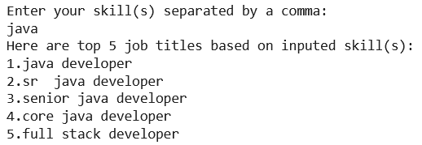
This logistic regression machine learning model was chosen because it is simple and effective to set up. Not only can this model identify patterns in the data, but it can associate them with output labels utilizing multinomial classification to predict a specific job title among many. Logistic regression can also provide relevant insights into the information through the direction of associate and accuracy of its predictor was. This means that the chosen model can find out which skills are contributing most to a job title and which skills influenced that prediction. Another reason that this model was chosen was that it is relatively lightweight and can scale well to large datasets while not needing to raise computational power.

Validation
Since the model chosen was logistic regression, this meant that the learning category required was supervised. According to an article written by IMB in their discussion about supervised learning, “[…], is defined by its use of labeled datasets to train algorithms to classify data or predict outcomes accurately. As input data is fed into the model, the model adjusts its weights until it has been fitted appropriately.” (“What is machine learning?”, 2021). This process of learning helped with the validation of the algorithm. Meaning that the potential of overfitting or underfitting was diminished. Metrics that were used for testing the model’s performance included utilizing the classification report feature from the Python sklearn library from metrics. This report outputted the performance and displayed metrics such as precision, recall, f1-score, support, accuracy, macro average, and weighted average. The accuracy depicts that out of the 662 samples, 46% of the predictions were correct, the macro accuracy shows around a 50% performance of the model, and the weighted average depicts that the model has a better performance on the classes that are more frequent.
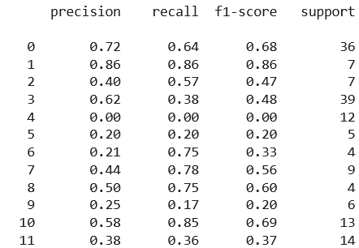
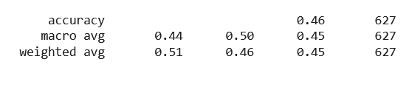
A second validation method was developed which utilized the confusion matrix and accuracy score portion of the sklearn library. This confusion matrix was used to summarize the overall performance of the logistic regression classification model. The accuracy report was used to compare the model’s predicted values with its true values. The results from both the confusion multi-class matrix and accuracy report depict that the model had decent performance at accurately classifying and predicting based on the large number of classes the solution has to use.
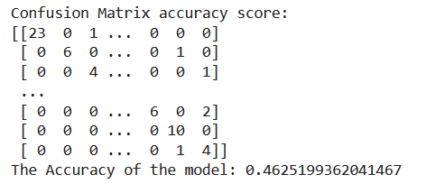

Visualizations
The first graph involved for this solution included a bar graph depicting the top twenty states in America that have the most amount of job postings on JobFinder Inc. The graph depicted that California was by far the state that had the most tech related jobs which makes sense with Silicon Valley being the tech hub of the USA. The state with the least amount of available offerings was in the state of Arizona.
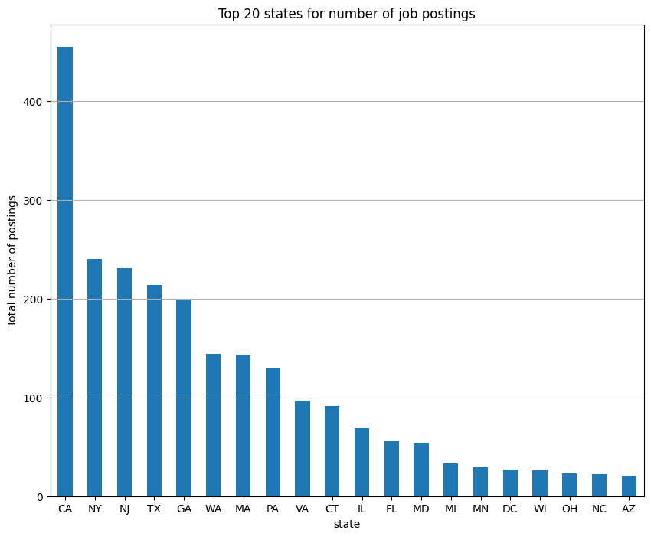
The second graph was a pie chart that shows the most popular job titles. The ones that have the most job postings on JobFinder Inc. The job titles are separated by differing colors with an included percentage of the total number of posts. Due to the high number of samples, the job title with the most postings was Java Developer followed by Project Manager. This finding shows users that Java Developer seemed to be the most in demand position when the data was pulled.
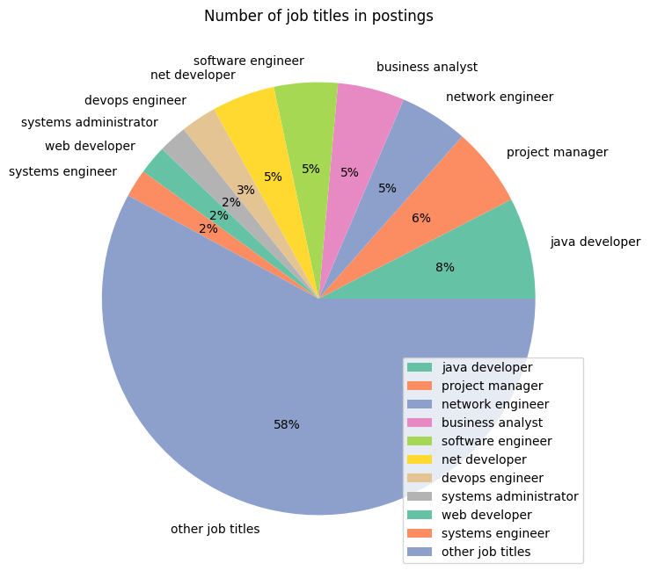
The third graph is a bar graph that shows the top 15 companies that have job postings on the company website. This shows which companies are doing the most hiring at the moment. This is valuable to users as it will help them discover which company they should be investigating and tooling their cover letters to match the business’ values. The graph educates customers on which companies they could research to make themselves more marketable and prepared for possible interviews.
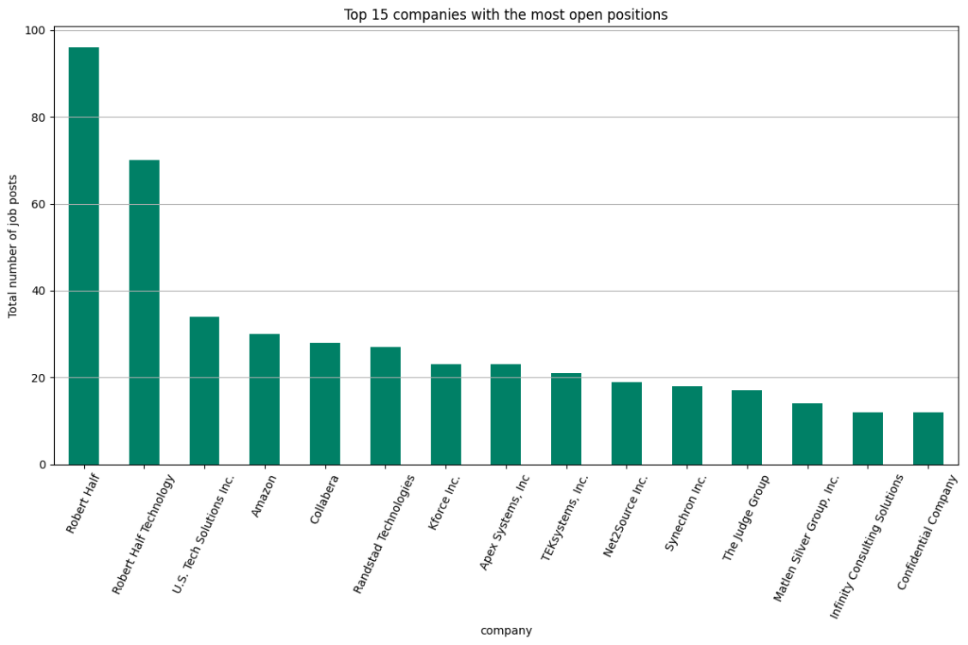

User Guide
This project is hosted on Google Colab for both ease of use and transparency. This hosted site provides a simple way of downloading the necessary requirements as well as the ability to almost instantly see what the code produces. The way Colab works is that there is a section of text followed by a section of Python code. This pattern repeats throughout the entire project. However, this project can also be used in JupyterLab via Binder reading the public Github repository. There will be walkthroughs for each version.
Using Project on Google Colab:
- Navigate to the following link: https://colab.research.google.com/drive/1kssoga2Tt6zUFbQS-Ft1ByZ-Kt8lEgJL?usp=sharing
- Either click the “Run All” button underneath the main nav bar or go section by section.
- For manually going section by section:
  - Next to the section of Python code under “Import all required libraries”, click the Play Button when it appears as the mouse hovers over the top left corner. This step will import all the necessary requirements to run the project.
  - Next to the section of Python code under “Read the csv file”, click the Play Button when it appears as the mouse hovers over the top left corner. This step will import the csv file from a public GitHub account so that the user doesn’t need to upload the data file anywhere.
  - For the rest of the section, repeat the same process. Underneath the text title section descripting what is happening in the Python code section below, there is the Play Button at the top left of the code section that needs to be manually selected.
- At the bottom of the Colab section, there is a section for user interaction. After either “Run All” or run section by section, there will be a user interface for interaction. This menu will ask for the user to enter skills separated by a comma or enter ‘exit’.
  - Enter skills the user wishes to search by
    - ex: java, python, html
  - Run section again for repeat use
Using Project on Binder/JupyterLab:
- Navigate to the following link: https://2i2c.mybinder.org/v2/gh/ZGrootegoed/Capstone/main
  - This link will lead to Binder reading the Github repository and creating a JupyterLab dashboard.
- Once the JupyterLab dashboard is loaded, on the side menu with all the files click on the kernelRequirements file.
  - Click the “Run this cell and advance” button on the Notebook taskbar for the ipynb file. Wait until the dashboard finishes downloading all the necessary requirements for the kernel to function.
- Then click on the jobsML file to open it.
- Then click on the “Run this cell and advance” button on the Notebook taskbar for the ipynb file to go section by section.
- At the bottom of the notebook, there is a section for user interaction. After either “Run All” or run section by section, there will be a user interface for interaction. This menu will ask for the user to enter skills separated by a comma or enter ‘exit’.
  - Enter skills the user wishes to search by
    - ex: java, python, html
  - Run section again for repeat use

Reference Page
Lee, E. (2024, February 10). Text preprocessing and classification with logistic regression. Medium. https://drlee.io/text-preprocessing-and-classification-with-logistic-regression-ea4fe3cfcaac
Lee, F. (2025, May 14). What is logistic regression?. IBM. https://www.ibm.com/think/topics/logistic-regression
Murel, J., & Kavlakoglu, E. (2023, December 10). What are stemming and lemmatization?. IBM. https://www.ibm.com/think/topics/stemming-lemmatization
Ng, C. (2023, April 1). Semma vs CRISP-DM: The differences. Starburst. https://www.starburst.io/blog/semma-vs-crisp-dm/
What is machine learning (ML)?. IBM. (2021, September 22). https://www.ibm.com/think/topics/machine-learning

